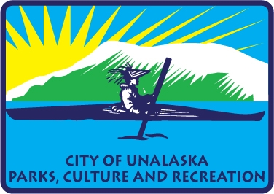

Agenda

If you want to participate, give information, or comments at the meeting please call 907-581-1297 or email [rblakeley@ci.unalaska.ak.us](mailto:rblakeley@ci.unalaska.ak.us) or attend in person.

**City of Unalaska | Department of Parks, Culture and Recreation**

**Advisory Committee Meeting | Conference Room**

**April 21, 2025, from 5:30 p.m. to 7:00 p.m.**

**Call to Order**

**Roll Call**

Thomas Roufos, Chair

Greg Peters

Ben Knowles

Jill Spetz

Avril Straub

Kim Hankins

Roger Blakeley, PCR Director

**Recognition of Visitors: Jolene Longo, Jackie Adams**

**Additions and Approval of Minutes of March 17, 2025**

**New Business:**

**$200,000 Feasibility Study presented to City Council for Pool and multi-use center**

**Business plans-PDF**

**Start of Softball season status of infield mix-Public Works.**

**Concession Stand- small appliances.**

**Grants**

**Pool- Undetermined- USA Swimming-April**

**Park Amenities- $47,764- March**

**Art program- Undetermined- June**

**Softball/Little League-Two possible grants**

**Old Business**

**Committee Members Comments**

**Next Meeting May 19, 2025**