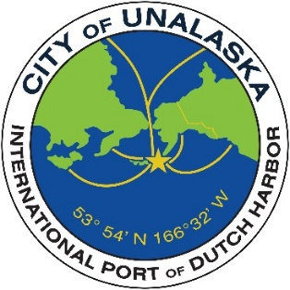
CITY OF UNALASKA
Request for Proposals
City of Unalaska – Department of Parks, Culture and Recreation
Aquatic Center Energy Audit
The City of Unalaska is seeking proposals from qualified firms to perform a comprehensive energy audit of the Unalaska Aquatic Center. The goal of this audit is to identify opportunities to improve energy efficiency, reduce operating costs, and extend the life of facility systems.
Facility Overview
The Aquatic Center was originally constructed in 1981 and renovated in 2006 and 2016. The facility includes a natatorium with a 25-yard, six-lane lap pool, warming alcove, open flume slide, and dry sauna.
Mechanical systems include an HVAC system and a pump room with an onsite chlorine generator, UV system, sand and gravel filters, chemical controls, and three primary pumps serving the pool, alcove, and slide.
Additional mezzanine-level spaces include the HVAC fan room, boiler room, and server room.
Scope of Work
The selected firm will perform a comprehensive energy audit of the Aquatic Center. The audit shall include, at a minimum, the following:
- Review historical energy usage, including utility bills and consumption trends.
- Conduct a site visit to inspect major energy-consuming equipment and systems.
- Identify areas of energy inefficiency within the facility.
- Develop recommendations for energy conservation measures (ECMs).
- Provide estimated implementation costs, projected energy savings, and return on investment (ROI) for recommended improvements.
Recommendations should be prioritized based on cost-effectiveness, feasibility and overall impact.
Deliverables
The final deliverable shall include a written report summarizing findings, recommended improvements, estimated costs, projected energy savings, and implementation priorities.
At a minimum, the report shall:
- Identify all recommended energy conservation measures (ECMs).
- Include cost estimates and projected payback or return on investment for each recommendation.
- Prioritize recommendations based on feasibility and impact.
- Provide supporting data and assumptions used in the analysis.
Qualifications
- Relevant professional certification.
- Examples of past projects, including scope and outcomes.
- Familiarity with energy systems commonly found in aquatic facilities, including HVAC systems, boilers and pool systems.
Schedule
- RFP Issued: March 19, 2026
- Proposal Due Date: April 20, 2026
- Project Completion: June 30, 2026
Submission Requirements
Proposals shall include the following:
- Firm overview and qualifications.
- Description of proposed approach to the project.
- Relevant experience with similar projects.
- Proposed project timeline.
- Fee proposal, including a breakdown of costs.
Evaluation Criteria
- Experience and qualifications.
- Approach to the project, including clarity and completeness of proposed deliverables.
- Cost
Proposal Submission Requirements and Information
Proposals must be submitted to the City Clerk at emagdaong@unalaska.gov no later than 5:00 p.m. Alaska Time Monday, April 20, 2026. Proposals should be submitted via email. It is the respondent’s sole and independent responsibility to timely submit proposals. Late submissions will not be considered. The City of Unalaska reserves the right to reject any or all proposals, waive informalities, and accept the proposal deemed in the best interest of the City.
All questions and inquiries should be directed to:
Amanda Schmahl
Aquatics Manager
aschmahl@unalaska.gov
907 359 4153

