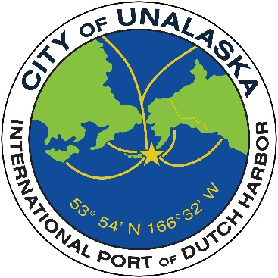

CITY OF UNALASKA
Request for Proposals
City of Unalaska – Department of Parks, Culture and Recreation
LED Lighting Replacement Project
1. Introduction
The City of Unalaska, Department of Parks, Culture and Recreation (PCR), is seeking qualified contractors to provide proposals for the replacement of existing lighting systems with energy-efficient LED lighting in the following facilities:
- Unalaska Community Center
- Burma Road Chapel
- Henry Swanson House
- Aquatic Center
The intent of this project is to improve energy efficiency, reduce maintenance costs, and enhance lighting quality within these facilities.

2. Scope of Work
The selected contractor shall provide all labor, materials, equipment, and supervision necessary to complete the following:
- Remove and properly dispose of existing lighting fixtures and components
- Supply and install new LED lighting fixtures throughout each facility
- Retrofit or replace fixtures as required to meet current electrical and energy codes
- Ensure all lighting meets appropriate illumination levels for each space
- Minimize disruption to facility operations during installation
- Perform testing, commissioning, and final adjustments of installed systems
- Provide product data, warranties, and as-built documentation upon completion

3. Qualifications
Proposers must demonstrate:
- Experience with commercial or municipal LED lighting retrofit projects
- Appropriate business licensing and ability to work in the State of Alaska
- Knowledge of applicable electrical codes and safety standards
- Ability to complete work within an agreed-upon schedule

4. Proposal Requirements
- Build America, Buy America: This project is partially or fully grant funded. All furnished materials shall be made in America as required by the United States Office of Management and Budget. See federal requirements (madeinamerica.gov) for details.
Proposals shall include:
- Company background and relevant project experience
- Project approach and timeline
- Detailed cost estimate (labor, materials, equipment)
- Product specifications for proposed LED fixtures

5. Schedule
- RFP Issued: 3/19/26
- Proposal Due Date:4/20/2026
- Project Completion: 6/30/2026

6. Selection Criteria
Proposals will be evaluated based on:
- Relevant experience and qualifications
- Cost-effectiveness
- Project timeline
- Quality and suitability of proposed materials

8. Additional Information
The City of Unalaska reserves the right to reject any or all proposals, waive informalities, and accept the proposal deemed in the best interest of the City.

8. Submission Instructions and Deadline
Proposals must be received by the Unalaska City Clerk no later than 5:00 p.m. Alaska Time on Monday, April 20, 2026. Proposals may be delivered via email, U. S. Mail, other delivery service or by hand delivery. Late submissions will not be considered.

City Clerk
City of Unalaska
43 Raven Way
P. O. Box 610
Unalaska, AK 99685
Email: emagdaong@unalaska.gov

Contact Information: For questions or further information about this RFP, please contact:

Jolene Longo
Business and Operations Manager
City of Unalaska
Parks, Culture & Recreation
P. O. Box 610
Unalaska, Ak 99685
(907) 581-1297
Email: jlongo@unalaska.gov

