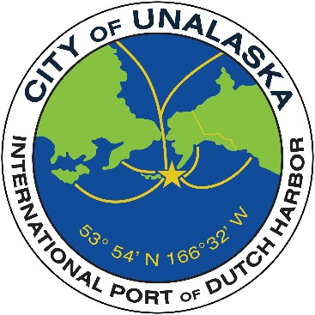
CITY OF UNALASKA
Request for Proposals
Tour Services
August 2025 ARCC

INTRODUCTION:
The City of Unalaska is requesting proposals from qualified tour operators to provide a variety of guided tour services, including hiking, boating, and birding experiences. These services will support the City’s mission to offer high-quality recreational opportunities and cultural tours for our upcoming ARC conference taking place August 12th -August 16th 2025.

OVERVIEW:
The City seeks to partner with an experienced and professional tour service provider to develop and offer safe and engaging outdoor tours throughout the Unalaska area. The selected provider(s) will offer scheduled and private tour options, with a strong emphasis on environmental education, cultural sensitivity, and visitor safety.
Tours should take advantage of Unalaska’s natural beauty, wildlife and historical significance. Proposals must include a cost structure, tour descriptions, and logistical requirements. Selected vendors will operate under a formal agreement with the City of Unalaska.
Tour categories sought include hiking, birding, whale watching, fishing and church/history tours.

PROPOSAL REQUIREMENTS:
Interested tour operators must submit the following:
- Cover Letter: Expressing interest in the RFP and identifying the individual and company name, physical and mailing address, email, and telephone contact.
- Detailed Proposal including:
  - Description of proposed tour types (hiking, boating, birding) with estimated group sizes, durations, and itineraries.
  - Fee schedule for each type of tour (per person, group, private, etc.).
  - Qualifications and experience in delivering outdoor adventure and nature-based tourism.
  - Description of safety measures and protocols.
  - Overview of staffing, training, and required certifications (e.g., wilderness first aid, boat captain license, birding expertise).
  - Information on necessary equipment (boats, gear, binoculars, etc.).
  - Insurance coverage or ability to acquire required coverage.
  - Any support or infrastructure required from the City (e.g., access to docks, parking, facilities).
  - Accessibility and fitness level required.
  - Tours must depart and return the same day.

SERVICE AGREEMENT TERMS:
- Cost and Revenue Sharing (if applicable):
  - Proposed pricing structure for tours.
  - Any proposed revenue-sharing model with the City (optional).
- Vendor Responsibilities:
  - Conduct all tours with qualified guides.
  - Provide all necessary equipment and safety gear.
  - Maintain compliance with relevant local, state, and federal regulations.
  - Provide insurance coverage and liability waivers for participants.
  - Maintain excellent customer service and handle all inquiries, complaints, and logistics.
  - Communicate promptly with the City regarding weather and capacity changes.
  - Collect payments through a city-coordinated booking process.
- City Responsibilities:
  - Provide access to agreed-upon public facilities (if requested and approved).
  - Collaborate on marketing and promotional efforts (as applicable).
  - Maintain a working liaison for coordination and support.
  - Notify selected vendors of final tour sign-ups by August 1, 2025.
- Insurance Requirements:
  - The tour provider must maintain general liability insurance that includes the City of Unalaska as an additional insured. Coverage must include personal injury and property damage resulting from tour operations.

DEADLINE:
Proposals must be received by the Unalaska City Clerk no later than 5:00 p.m. Alaska Time on Friday, July 7, 2025. Proposals may be submitted by email, U.S. mail, courier, or hand delivery. Late submissions will not be considered.
Submit Proposals To:
City Clerk
City of Unalaska
43 Raven Way
P.O. Box 610
Unalaska, AK 99685
Email: emagdaong@ci.unalaska.ak.us

CONTACT INFORMATION:
For questions or further information about this RFP, please contact:
Jolene Longo
Business and Operations Manager
City of Unalaska – Parks, Culture & Recreation
P.O. Box 610
Unalaska, AK 99685
(907) 581-1297
Email: jlongo@ci.unalaska.ak.us

